Week 4: order management system
1. Create ORDERS Table
Created the ORDERS table with:
- Order _ID
- Customer _ID
- Order _Date
- Total _Amount
- Order _Status
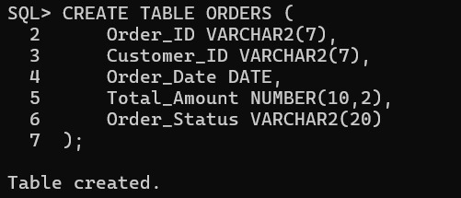
2. Create ORDER_DETAILS Table
Created the ORDER_DETAILS table with:
- Order _Detail _ID
- Order _ID
- Product _ID
- Quantity
- Price
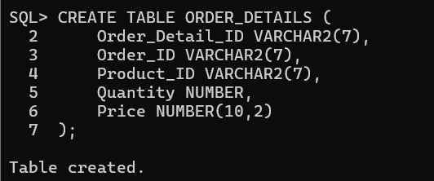

3. Establish Relationship
Primary Key
Order:
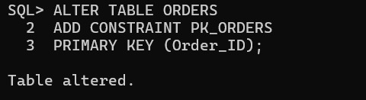
Order_ details:
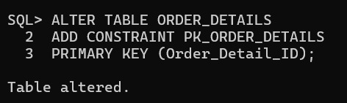
Foreign Key
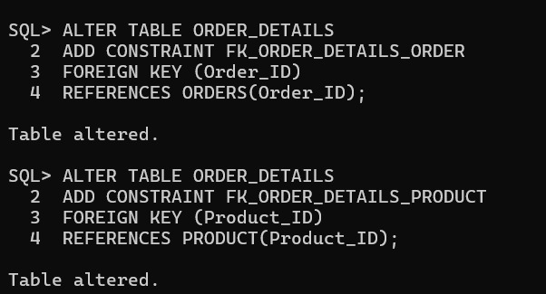
NOT NULL
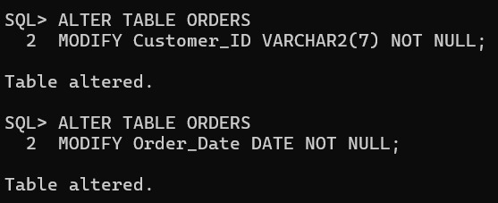
CHECK
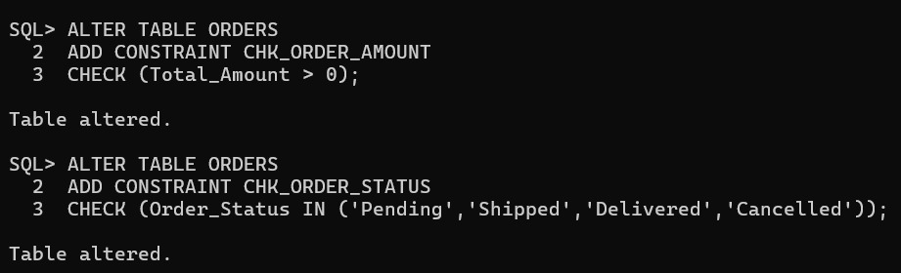
UNIQUE
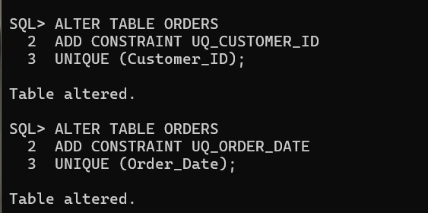
4. Insertion values
Order values
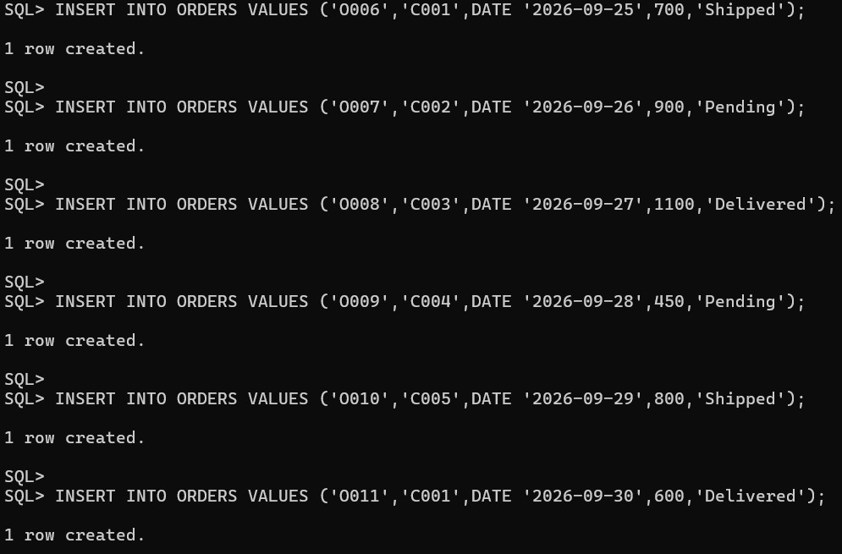
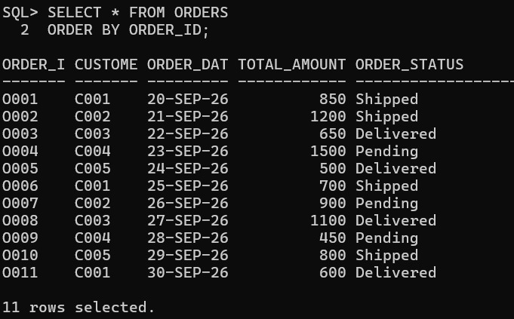
Order_ details
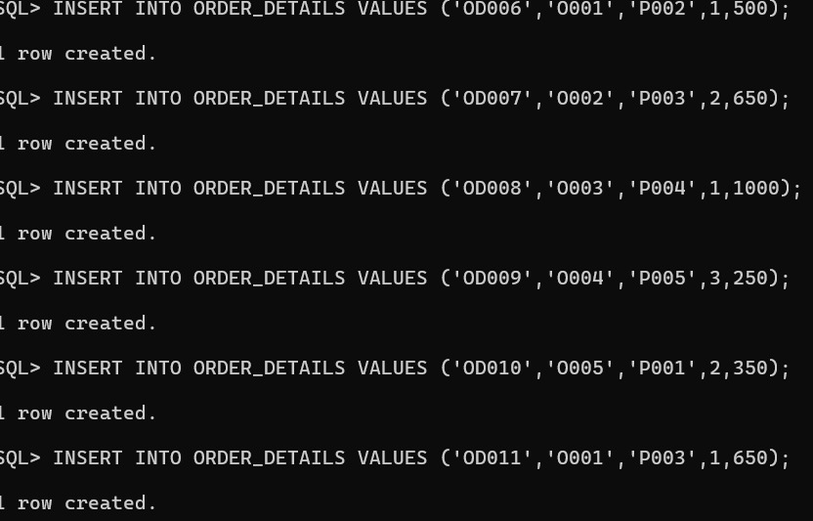
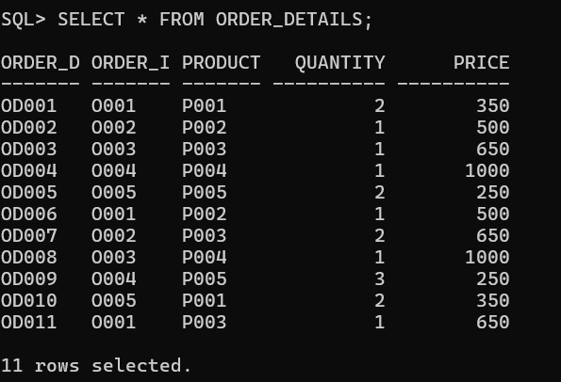
Report : 1 Customer Order History
- Customer Name
- Order ID
- Order Date
- Total Amount
- Status
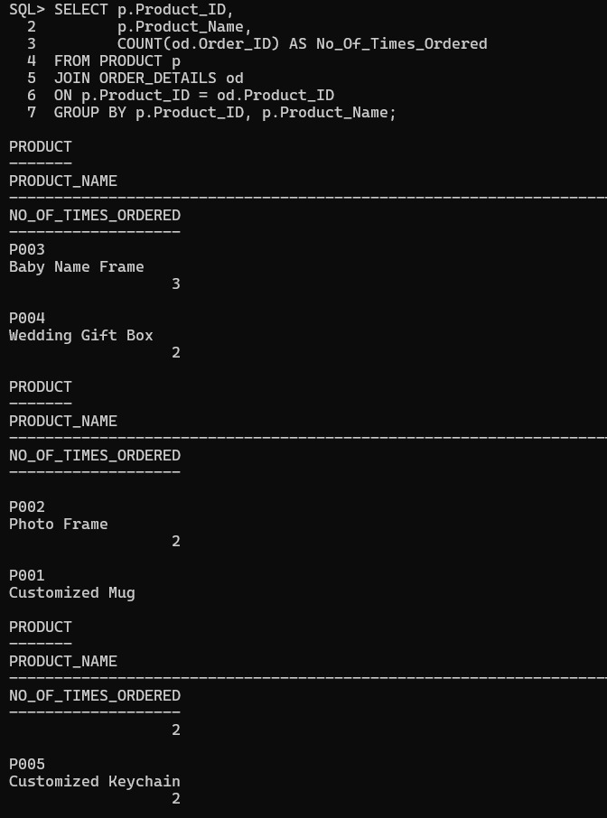

Report 2 – Product-wise Order Report
- Number of times each product was ordered
- Total quantity sold
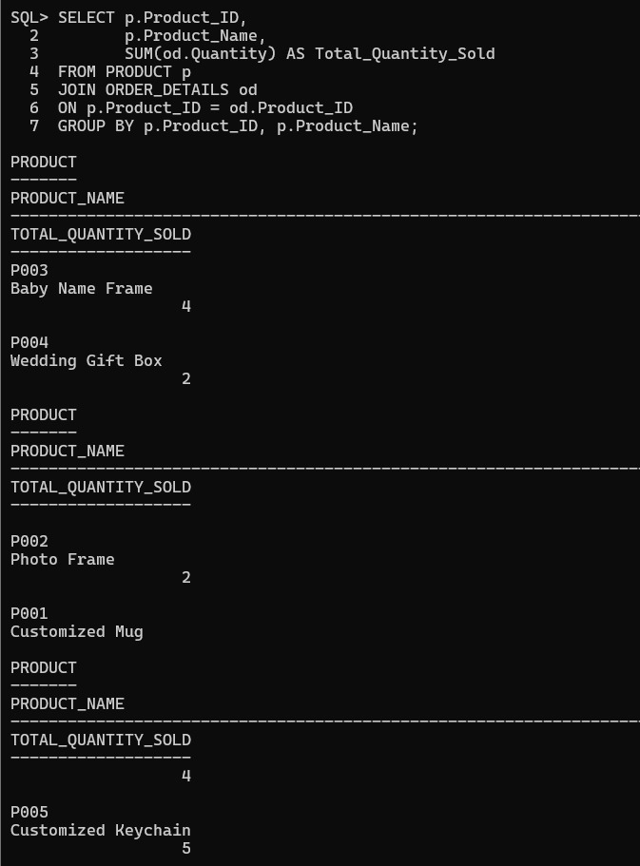

Report 3 – Customer Purchase Analysis
- Customers with maximum orders
- Total spending by each customer
- Average order value
